

COMSATS University Islamabad, Lahore Campus

QUIZ-2 – FALL 2024
Course Title: | Software Project Management |  |  |  |  | Course Code: |  | CSE494 |  | Credit Hours: | 3(2,1)
Course instructor/s: | Humaira Afzal |  |  |  | Program Name: |  |  | BS Software Engineering
Semester: | 7th | Batch: | FA21-BSE | Section: | A |  |  | Date: | 22-10-2024
Time Allowed: | 45 Minutes |  |  |  | Maximum Marks: |  |  |  | 20
Student’s Name: |  |  |  |  | Reg. No.

Question : [Marks:8+12=20]
CLO: <2>; Bloom Taxonomy Level: <Applying>

Consider the following case study and answers the questions given at the end of this case study

A software development company is building a tourism management system for a travel agency. The system is intended to manage bookings, itineraries, and customer details. During the project’s execution phase, the client requests additional features such as integrating real-time weather updates and social media sharing capabilities. These were not included in the original project scope.

As the project manager, how would you apply scope change control processes to assess the feasibility of these new requests and manage their integration into the project without affecting the timeline and budget? (Marks:08)

Based on the above case study, the activities, their duration and dependencies are given below:

Tasks | Activities | Predecessors | Duration
Requirement Analysis | A | None | 10 Days
System Design | B | A | 15 Days
User Authentication and Authorization | C | B | 20 Days
Account Management | D | B | 25 Days
Funds Transfer | E | B | 15 Days
Bill Payments | F | B | 10 Days
Customer Support | G | B | 10 Days
Reporting and Analytics | H | B | 20 Days
Security and Compliance Review | I | C, D, E, F, G, H | 10 Days
Integration testing | J | I | 15 Days
User Acceptance Testing | K | J | 10 Days
Deployment | L | K | 5 days

- Create a Network Diagram (6 Marks)

Draw an activity-on-node (AoN) network diagram for this project, using a standard node convention to display the duration.

- Identify the Critical Path (4 Marks):

Analyze the network diagram and determine the critical path for the project.
- Apply forward and backward passes.
- Calculate Float.

- Determine the Project Duration (2 Marks):

What is the overall duration of the project based on the critical path?

Solution

Question : [Marks:8+12=20]
CLO: <2>; Bloom Taxonomy Level: <Applying>

Consider the following case study and answers the questions given at the end of this case study

A software development company is building a tourism management system for a travel agency. The system is intended to manage bookings, itineraries, and customer details. During the project’s execution phase, the client requests additional features such as integrating real-time weather updates and social media sharing capabilities. These were not included in the original project scope.

As the project manager, how would you apply scope change control processes to assess the feasibility of these new requests and manage their integration into the project without affecting the timeline and budget? (Marks:08)

Solution:

To manage the additional feature requests, the following scope change control processes can be applied:

1. Evaluate the Change Request: Initiate a formal change request process. Document the client’s request for integrating real-time weather updates and social media sharing features. Determine how these changes align with the original project objectives.

2. Impact Assessment: Conduct an impact analysis to evaluate how these new features will affect the project’s timeline, budget, resources, and existing functionalities. This should include consultations with the development team, testing team, and possibly third-party vendors (for real-time weather data).

3. Prioritize Requirements: Engage with the client to prioritize the new requests. Discuss whether these features are essential for the current release or if they could be included in a future phase.

4. Update the Scope Statement: If the changes are approved, update the scope statement and other project documents, ensuring the work breakdown structure (WBS) reflects the added features.

5. Adjust the Schedule and Budget (if necessary): If the additional features impact the timeline or budget, negotiate these changes with the client and update the project plan.

6. Communicate the Changes: Ensure all stakeholders, including the development team, testers, and clients, are informed of the approved changes, the impact on the project, and any new deadlines.

Based on the above case study, the activities, their duration and dependencies are given below:

Tasks | Activities | Predecessors | Duration
Requirement Analysis | A | None | 10 Days
System Design | B | A | 15 Days
User Authentication and Authorization | C | B | 20 Days
Account Management | D | B | 25 Days
Funds Transfer | E | B | 15 Days
Bill Payments | F | B | 10 Days
Customer Support | G | B | 10 Days
Reporting and Analytics | H | B | 20 Days
Security and Compliance Review | I | C, D, E, F, G, H | 10 Days
Integration testing | J | I | 15 Days
User Acceptance Testing | K | J | 10 Days
Deployment | L | K | 5 days

- Create a Network Diagram (6 Marks)

Draw an activity-on-node or activity on arrow network diagram for this project, using a standard node convention to display the duration.

- Identify the Critical Path (4 Marks):

Analyze the network diagram and determine the critical path for the project.
- Apply forward and backward passes.
- Calculate Float.

- Determine the Project Duration (2 Marks):

What is the overall duration of the project based on the critical path?

Solution:

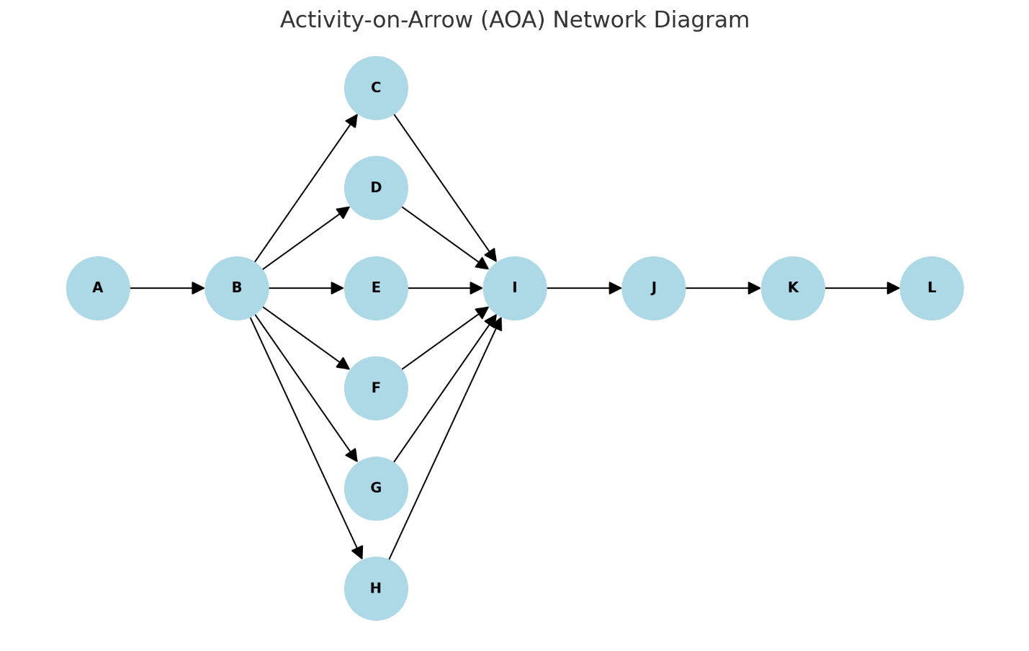

Forward and Backward Pass

Forward Pass
The forward pass calculates the earliest start times for each activity:
A: Earliest Start (ES) = 0, Earliest Finish (EF) = 10
B: ES = 10, EF = 25
C: ES = 25, EF = 45
D: ES = 25, EF = 50
E: ES = 25, EF = 40
F: ES = 25, EF = 35
G: ES = 25, EF = 35
H: ES = 25, EF = 45
I: ES = 50, EF = 60
J: ES = 60, EF = 75
K: ES = 75, EF = 85
L: ES = 85, EF = 90

Backward Pass
The backward pass calculates the latest finish times for each activity:
L: Latest Start (LS) = 85, Latest Finish (LF) = 90
K: LS = 75, LF = 85
J: LS = 60, LF = 75
I: LS = 50, LF = 60
H: LS = 25, LF = 45
G: LS = 40, LF = 50
F: LS = 40, LF = 50
E: LS = 35, LF = 50
D: LS = 25, LF = 50
C: LS = 45, LF = 50
B: LS = 10, LF = 25
A: LS = 0, LF = 10

Critical Path Calculation

Slack Calculation
Slack time for each activity is calculated as follows:
A: 0
B: 0
C: 5
D: 0
E: 10
F: 15
G: 15
H: 5
I: 0
J: 0
K: 0
L: 0
Critical Path Activities: A -> B -> D -> I -> J -> K -> L
Total Project Duration: 90 days

